Kidstar Academy
COMPETENCY BASED CURRICULUM
GRADE 1 - TERM 1 2022 – HYGIENE AND NUTRITION ACTIVITIES
NAME: SCHOOL
- We use_________ to cook tea (milk, maize)
- Cows gives us ____ ( milk, millet )
- We always brush our teeth ____ meals (Before, After )

- We should not play with _________ (knives, toys )
- Sick people go to ______( hospitals, market )
- We take __________ to feel better when sick ( alcohol, medicine )
- Teeth that are removed are called_______ ( milk teeth, permanent teeth )
- _____ is used to clean our nose (handkerchief, tissue )
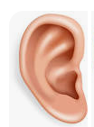
Name pictures below
- _______

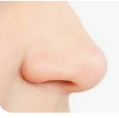
- ______

- __________
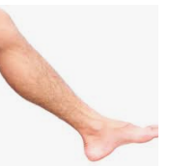

- __________

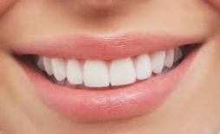

- Dirty fruits make us ______ ( healthy, sick)
- We should not eat _______ bananas (rotten, clean )
Draw the following fruits
- Mango

- Orange

- We should always keep medicines in the _______ ( store, curd board)
- We should not take _____ drugs (expired, prescribed drugs )
- Too much sugar is ____ to our health ( good, bad )

