KNEC GRADE 6 EXAMS KPSEA FIRST TRIAL- 22

CLASS OF KPSEA NOVEMBER 2022


THE KENYA NATIONAL EXAMINATIONS COUNCIL
Kenya Primary School Education Assessment

MATHEMATICS
Grade 6

1 hour 20 minutes
INSTRUCTIONS TO CANDIDATES (Please read these instructions carefully)

- You have been given this question booklet and a separate answer sheet. The question booklet contains 30 questions.
- Do any necessary rough work in this booklet.
- When you have chosen your answer, mark it on the ANSWER SHEET, not in this question booklet.
HOW TO USE THE ANSWER SHEET
- Use an ordinary pencil.
- Confirm that the answer sheet that you have been provided with has the following:
YOUR ASSESSMENT NUMBER YOUR NAME
NAME OF YOUR SCHOOL NAME OF SUBJECT
- Do not make any marks outside the boxes.

- Keep the sheet as clean as possible and do not fold it.

- For each of the questions 1 – 30, four choices are given. The choices are lettered A, B, C and D. In each case, only
ONE of the four choices is correct. Choose the correct answer from the choices.

- On the answer sheet, the correct answer is to be shown by drawing a dark line inside the box in which the letter you have chosen is written.

Example
In the Question Booklet:
11. Work out 2 × 18 + 7
A. | 252
B. | 50
C. | 43
D | 27
The correct answer is C (43).
On the Answer Sheet:
In the set of boxes numbered 11, draw a dark line inside the box with the letter C printed in it as indicated below.
11 [A] [B] [C] [D]

- Your dark line MUST be within the box.
- For each question, ONLY ONE box is to be marked in each set of four boxes.
This question paper consists of 11 printed pages
© 2022 The Kenya National Examinations Council

  - There were sixty five thousand and fifty people who attended an agricultural show. What is the number of people in symbols?
A. 60550
B. 65550
C. 60505
D. 65050
  - At the beginning of the year, there were 1204 learners in a school. By the end of the year, 132 learners left the school. At the beginning of the following year, 214 joined the school. How many learners are there in the school now?
A. 1550
B. 1286
C. 1122
D. 858
  - A teacher displayed the following number cards to the learners.
24362
24362
52628

A learner rounded off each number in the cards to the nearest hundreds. What was the sum of the rounded numbers?
A. 76990
B. 77000
C. 77010
D. 77100
  - A factory produced 7435 pieces of soap. The workers packed 1263 pieces of the soap. How many pieces of soap were not packed?
A. 6172
B. 6232
C. 6272
D. 8698

Working Space

  - A lorry carried 452 cartons of books. Each carton had 24 books. How many books did the lorry carry altogether?
A. 11848
B. 10848
C. 9648
D. 2712
  - Work out
64 ÷ 4 × 2 + 8
A. 160
B. 40
C. 16
D. 4
  - Musa divided his piece of land as shown.

Working Space

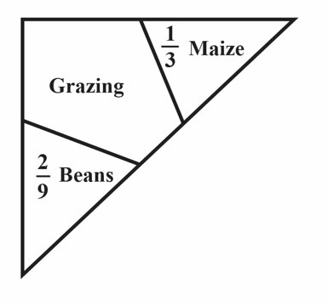
Maize covered ¹
3

of the piece of land while beans

covered ²
$
of the piece of land. What fraction of the

land was left for grazing?
    - 2
3

    - %
$

    - &
$

    - 7
$

  - Arrange the fractions ²
3
, 3 , 1
% 2
from the smallest to

Working Space

the largest. Which one of the following is the correct arrangement?

    - 1
2
    - 2
3
    - 3
%
    - 1
2
, 3 , 2
% 3

, 1 , 3
2 %

, 1 , 2
2 3

, 2 , 3
3 %

  - A trader arranged her green grocery for sale as shown.
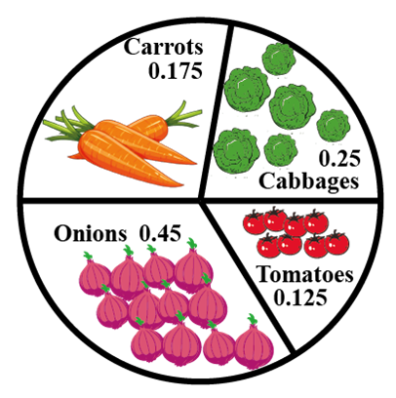
What portion was covered by cabbages, tomatoes and onions?
A. 0.825
B. 0.700
C. 0.575
D. 0.175

  - Arrange the following decimals 0.75, 1.25, 0.8, 1.135 from the largest to the smallest. Which one of the following is the correct arrangement?

A. 0.75, 0.8, 1.135, 1.25
B. 0.75, 1.135, 1.25, 0.8
C. 1.135, 1.25, 0.8, 0.75
D. 1.25, 1.135, 0.8, 0.75

  - The track shown measures 21 m 45 cm. Working Space
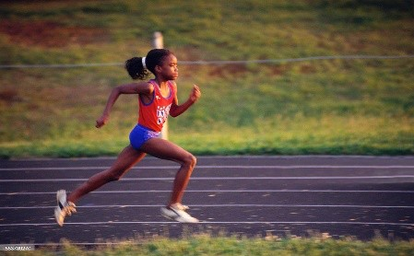
Neema ran on the track three times. What distance did she cover?

    - 7 m 15 cm
    - 42 m 90 cm
    - 64 m 35 cm
    - 128 m 70 cm

  - A block of wood is 3 metres long. What is the length of the block of wood in centimetres?
A. 30
B. 300
C. 3000
D. 30000

  - Find the perimeter of the shape shown.
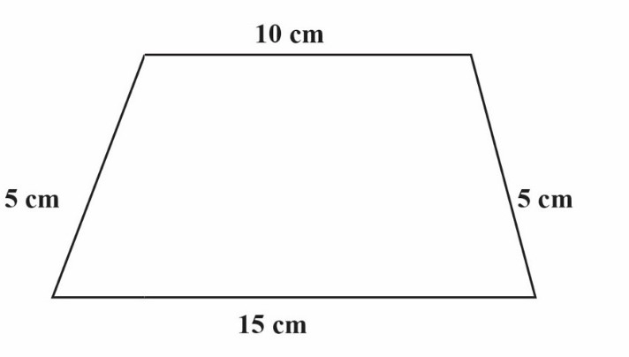
    - 20 cm
    - 25 cm
    - 30 cm
    - 35 cm

  - The figure shows a rectangle divided into unit squares. Working Space

What is the area of the rectangle?
A. 35
B. 20
C. 12
D. 5

  - Patel had a sh 1000 note. He changed the money into different denominations. Which one of the following represents the correct change?

A. sh 500 + sh 200 + sh 100 + sh 50 + sh 50
B. sh 200 + sh 200 + sh 200 + sh 200 + sh 100 + sh 50
C. sh 500 + sh 200 + sh 100 + sh 100 + sh 50
D. sh 500 + sh 200 + sh 200 + sh 100

  - A construction worker bought 175 kg of cement, 473 kg of sand and 282 kg of ballast. What is the total mass of the materials bought?

    - 930 kg
    - 755 kg
    - 648 kg
    - 457 kg

  - What is the next missing number in the pattern?

10, 12, 16, 24, 40,

A. 32
B. 42
C. 64
D. 72

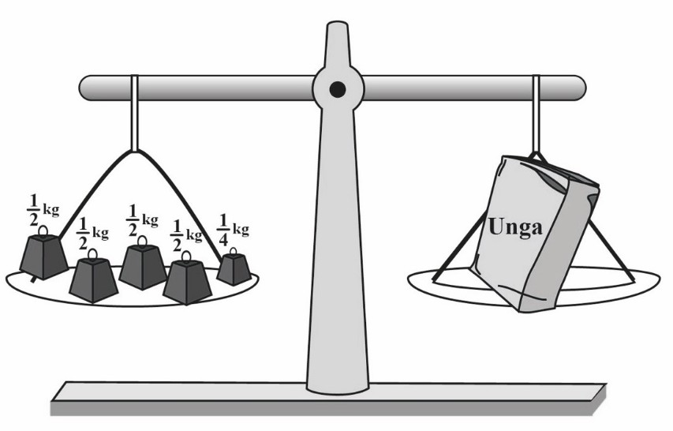Working Space
The beam balance shown was used to measure the mass of unga.
What is the mass of unga in kilograms?
A.
B.
C.
D.
5
21
%
2
1 1
%
A trader bought 260 kg of sugar. He then sold 175 kg of the sugar. Later, the trader bought 195 kg to add to the remainder. How many kilograms of sugar does the trader have now?
A.
B.
C.
D.
20
85
280
455
The figure shows a number on a place value chart.
What is the place value of digit 5 in the number?

- Tenths
- Hundredths
- Ones
- Thousandths

  - 19.

  - 20.
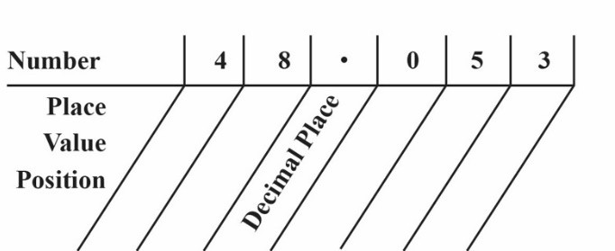

  - At a construction site, building blocks were arranged to form the stack as shown.
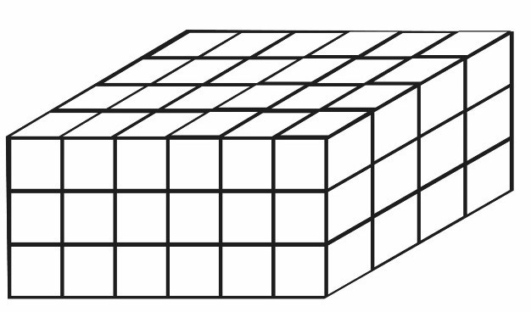

How many blocks are in the stack?
A. 18
B. 24
C. 54
D. 72

  - Jeru visited the grandmother for 13 days. How many weeks and days did Jeru take?

    - 1 week 3 days
    - 1 week 6 days
    - 2 weeks 0 days
    - 2 weeks 3 days

  - Asha started reading a story book in the morning as shown on the digital clock.

Working Space



She read the storybook for 1¹
2
hours. What time did

Asha stop reading the storybook?

A. 11.45 a.m
B. 11.45 p.m
C. 12.45 a.m
D. 12.45 p.m

  - The two clock faces shows the starting time and finishing time of a football match.
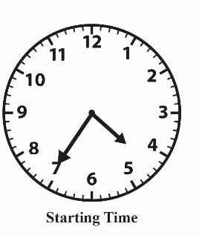
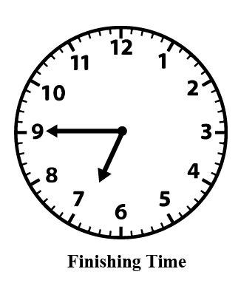
How long did the football match take?

    - 70 minutes
    - 120 minutes
    - 130 minutes
    - 190 minutes

  - Which one of the following lists shows money paid by the public to a county government of Kenya?

    - Land fees, school fees, parking fee, cess
    - Market fees, cess, business permit, security fee
    - Market fees, business permit, cess, parking fee
    - Land fees, security fee, business permit, parking fee

  - To get to school, Musa walks straight and then turns to the left. What kind of turn does Musa make?
Working Space

    - ¹
%
    - ¹
2
    - ³
%
turn turn turn

    - Full turn

  - The following is the price list for Furaha shop. Working Space
ITEM
A packet of milk A loaf of bread
A packet of tea leaves
PRICE
sh 55
sh 50
sh 45

Masudi bought 2 packets of milk, a loaf of bread and a packet of tea leaves. He gave the shopkeeper a sh 500 note. What was his balance?

    - sh 350
    - sh 295
    - sh 255
    - sh 205

  - Ann has some bananas. Tom has the same number of bananas as Ann. Tesse has 3 bananas. Represent the number of bananas Ann has as x. Form an expression to show the number of bananas they have altogether.

    - x + x + 3
    - x + 3
    - 3x + 3
    - 3x

  - The following are properties of some shapes.

- All angles are equal.
- Has 4 lines of symmetry.
- All sides are equal.

Which shape is represented by the above properties?

  - A right angled triangle
  - An equilateral triangle
  - A square
  - A rectangle

  - The table represents the number of new COVID-19 cases in various counties on a certain day. The cases for Nairobi county is not shown.

County | Frequency
Nairobi | -
Nakuru | 135
Garissa | 17
Kwale | 8
Kisii | 10

The total number of COVID-19 cases on that day was 656. What was the number of cases in Nairobi county on that day?
A. 170
B. 386
C. 486
D. 1142
Working Space

THE KENYA NATIONAL EXAMINATIONS COUNCIL
Kenya Primary School Education Assessment

ENGLISH LANGUAGE
Grade 6

1 Hour
INSTRUCTIONS TO CANDIDATES (Please read these instructions carefully)

- You have been given this question booklet and a separate answer sheet. The question booklet contains 30 questions.

- When you have chosen your answer, mark it on the ANSWER SHEET not in this question booklet.

HOW TO USE THE ANSWER SHEET
- Use an ordinary pencil.

- Confirm that the answer sheet provided with has the following:
YOUR ASSESSMENT NUMBER YOUR NAME
NAME OF YOUR SCHOOL NAME OF SUBJECT
- Do not make any marks outside the boxes.

- Keep the sheet as clean as possible and do not fold it.
- For each of the questions 1 – 30, four choices are given. The choices are lettered A, B, C and D. In each case, only
ONE of the four choices is correct. Choose the correct answer from the choices.

- On the answer sheet, the correct answer is to be shown by drawing a dark line inside the box in which the letter you have chosen is written.
Example
In the Question Booklet:
  - Choose the alternative that best completes the sentence.

We are working hard in school, ?
    - are we
    - isn’t it
    - aren’t we
    - don’t we
The correct answer is C.
On the answer sheet.
In the set of boxes numbered 15, draw a dark line inside the box with the letter C printed in it as indicated below.
15 [A] [B] [C] [D]

- Your dark line MUST be within the box.

- For each question, ONLY ONE box is to be marked in each set of four boxes.

This question paper consists of 7 printed pages

©2022 The Kenya National Examinations Council

Question 1 to 5

Read the following conversation and then answer questions 1 to 5.
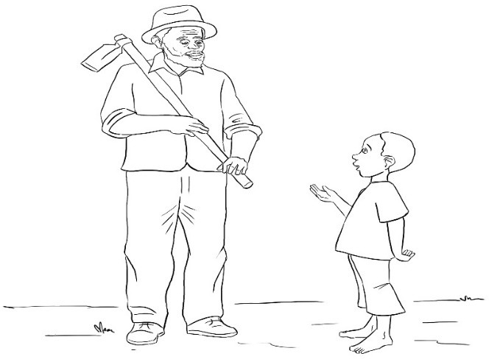

Tom: My father has sent me to ask you to lend him a
jembe.
Mr. Bakari: Good morning, Tom. Happy to see you.
Tom: I’m fine and you? Do you have a jembe? Mr. Bakari: Yes. I do. Is your father at home? Tom: Yes. He’s waiting for the jembe.
Mr. Bakari: Here, take the jembe, Tom. Tell your father that I will need it back tomorrow.
Tom: Goodbye, Bakari.

- Tom does not greet Mr. Bakari. This shows that Tom is .
  - impolite
  - lazy
  - impatient
  - selfish

- What should Tom say when Mr. Bakari says, “Happy to see you”?
  - Welcome.
  - Happy to see you too.
  - That’s very good.
  - Thanks.
- When Mr. Bakari said, “Good morning”, Tom should have said
  - Good morning to you, Mr. Bakari.
  - The morning is good, Mr. Bakari.
  - I am happy to see you, Mr. Bakari.
  - You are fine, Mr. Bakari.

- What should Mr. Bakari say after Tom says, “Goodbye”?
  - It’s okay.
  - Thank you.
  - See you tomorrow.
  - Goodbye to you too.

- What shows that Mr. Bakari has good manners?
  - He gives Tom a jembe.
  - He greets Tom.
  - He asks Tom questions.
  - He knows Tom’s father.

2

Read the passage below and then answer questions 6 to 9.

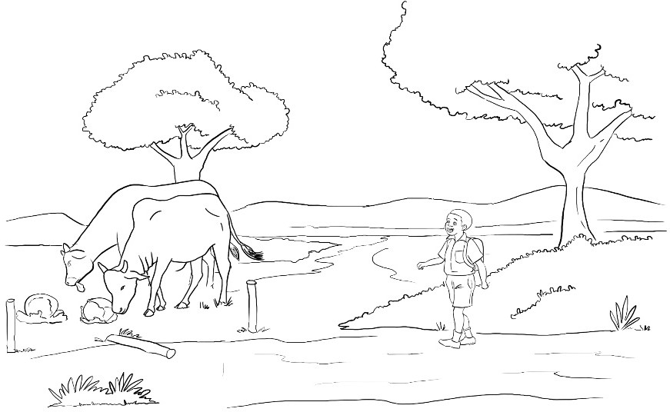One chilly morning, Kuchal woke up late. The sun was already up. He hastily pushed the blanket aside, folded his sleeping mat and bundled everything at a corner in his grandmother’s house. Kuchal then washed his face, legs and hands hastily. He immediately left for school.
On his way, Kuchal could see footprints of his schoolmates on the red soil. He was sure they were ahead of him. He tried to increase his pace. He was worried about getting to school
late. What would he tell the teacher? Suddenly, he heard a splash of water behind him. He turned and saw Lomel and Rotino.
“Good morning, Kuchal,” Lomel greeted him.
“Good morning Lomel. Happy to see …,” Kuchal replied.
“Kuchal, I can’t believe you are also late for school,” Rotino interrupted. “I woke up unusually late, my friends. I don’t know how it happened.”
The boys continued with their journey. The foot path passed through Mr. Charo’s farm. Inside the farm, there were some cows destroying crops. Kuchal asked his friends to help him to drive the animals from the farm. The boys refused and walked on. Kuchal then picked a stick and drove the animals out of the farm. Just then, he met Mr. Charo who had been searching for the animals.

- From the passage, Kuchal can best be described as .
  - responsible
  - courageous
  - hardworking
  - clever
- The word “hastily” as used in the passage means .
  - carelessly
  - angrily
  - loudly
  - hurriedly
3
- From the passage, we can say that
  - Kuchal was rarely late for school.
  - Mr. Charo did not fence his farm.
  - Lomel and Rotino are neighbours.
  - the school was very far from home.

- Which one of the following is the best title for the story?
  - Kuchal wakes up late
  - Kuchal and his friends
  - Kuchal and the cows
  - Kuchal goes to school

Read the passage below and then answer questions 10 to 12.

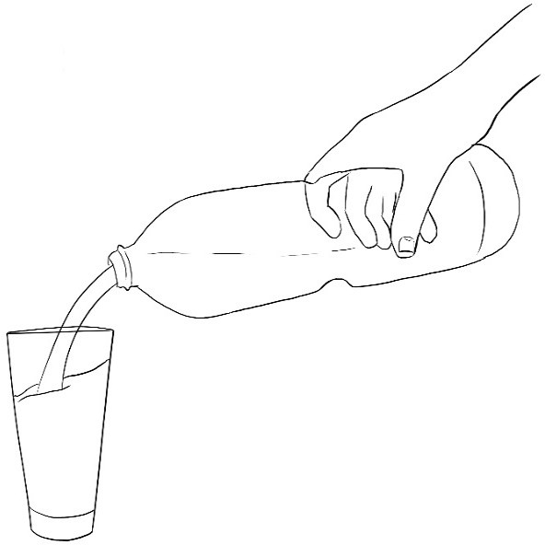It is important to ensure that water we drink is safe. Usually, in gatherings such as parties, weddings and other ceremonies people are served bottled drinking water. This has become fashionable over time. Bottled water is highly regarded because people assume that it is safe for drinking. This type of water is portable. This means that you can carry it around. Bottled water can be stored for a long time. Unlike tap water, the quality of bottled water is more likely to be of high quality because the
government controls how it is produced and packaged. However, not everything about bottled water is positive. In the first place, empty plastic bottles are a real health hazard in that they pollute the environment. Bottled water is also more expensive than tap water. Interestingly, bottled water can just be tap water. Greedy people can just pack tap water in bottles and claim it is safe for drinking. We should be careful about the water we drink.

- Why, according to the passage, do some people sell tap water in bottles?
  - They want to make money quickly.
  - They want everybody to drink water.
  - They do not have money to make water safe.
  - They do not know the danger of drinking tap water.

- What shows that the government cares about the health of its people?
  - It gives out bottles for storing water.
  - It ensures that bottled water is safe.
  - It discourages the use of empty bottles.
  - It ensures that bottled water reaches everybody.
- Which one of the following is true
according to the passage?
  - Not all bottled water is safe.
  - Bottled water is the best.
  - We should not drink tap water.
  - Tap water cannot be bottled.

4

Read the passage below and then answer questions 13 to 15.
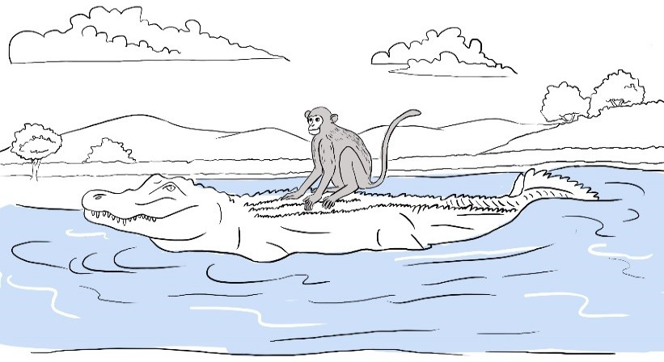
Once upon a time, Monkey and Crocodile were good friends. Monkey lived on a mango tree near a river. One day, Crocodile went to visit his friend. Monkey gave him a delicious mango from the tree. It was very juicy. Crocodile licked his fingers repeatedly as he ate the mango. He then thanked Monkey for the fruit and returned home. On his way home, Crocodile told himself that the heart of monkey must be very sweet because he eats the mangoes every day. He therefore started to plan how to eat Monkey’s heart.
The next day, Crocodile went to Monkey and said, “Friend, I would like to invite you to my house to thank you for the sweet mango.”
“But I don’t know how to swim,” said monkey.

“Don’t worry. I will carry you on my back,” Crocodile replied.
Monkey agreed and he sat on Crocodile’s back. In the middle of the river, Crocodile told Monkey, “I must eat your heart today.” Monkey was frightened but he remained still.
“I have left my heart up the mango tree,” he said calmly.

- Why did Crocodile lick his fingers repeatedly?
  - He liked mangoes very much.
  - He enjoyed eating the fruit.
  - He wanted more mangoes.
  - He was very hungry.
- From the passage, “he remained still” as used in the passage means .
  - Monkey did not smile
  - Monkey did not worry
  - Monkey did not move
  - Monkey did not talk

- What lesson do we learn from this story?
  - It is easy to make friends.
  - We should choose our friends wisely.
  - We should always listen to our friends.
  - It is good to visit our friends

5

Question 16 to 20

Read the passage below. It contains blank spaces numbered 16 to 20. For each blank space, select the best
alternative from the choices given.
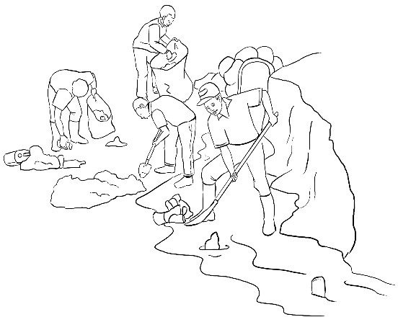
Pollution makes our environment unsafe. Pollution is the 16 that can make our soil, air or water harmful. We must therefore make sure that we 17 our environment clean. If we do not take care of our environment, we 18 become sick. At school, we must wash our toilets 19 classrooms. We must also wash our hands 20 soap and running water.

16. A. | method | B. | process | C. | way | D. | manner
17. A. | take | B. | put | C. | keep | D. | get
18. A. | may | B. | should | C. | must | D. | have
19. A. | even | B. | or | C. | and | D. | also
20. A. | with | B. | by | C. | in | D. | from

For questions 21 to 28, fill in the blank spaces with the correct alternatives from the choices given.

- Bonaya
yesterday.
  - wrote
  - write
  - written
  - writes
a good composition

- Nekesa is my friend. She can draw a picture of very well.
  - herself
  - himself
  - myself
  - yourself

- Mwajuma did not shake my hand. She waved me.
  - for
  - on
  - at
  - with

6

- Between the two green bags, one belongs to you?
  - which
  - what
  - that
  - this

- Ochieng’ bought a table for his grandmother.
  - round big plastic
  - plastic round big
  - big plastic round
  - big round plastic
- You are happy today, ?
  - are you
  - isn’t you
  - aren’t you
  - is you

- Maria could not give me sugar because she had in the cupboard.
  - little
  - some
  - a little
  - much
For questions 30, choose the word that means the
opposite of the underlined.

- The goats were feeding on dry leaves by the road.
  - soft
  - wet
  - hard
  - cold

THIS IS THE LAST PRINTED PAGE.

- Cherono jumped
winning the race.
  - properly
  - carefully
  - excitedly
  - easily
after

For question 29, choose the alternative that means the same as the underlined words.

- Mr. Kioko encouraged me to keep on
working hard in class.
  - continue
  - try
  - repeat
  - enjoy

7


THE KENYA NATIONAL EXAMINATIONS COUNCIL
Kenya Primary School Education Assessment

KISWAHILI LUGHA
Gredi ya 6

Muda: Saa 1
MAAGIZO KWA WATAHINIWA (Soma maagizo yafuatayo kwa makini)

- Umepewa kijitabu hiki cha Kiswahili na karatasi ya kujibia. Kijitabu hiki kina maswali 30.

- Ukiisha kuchagua jibu lako, lionyeshe katika KARATASI YA MAJIBU na wala sio katika kijitabu hiki cha maswali.
JINSI YA KUTUMIA KARATASI YA MAJIBU
- Tumia penseli ya kawaida.
- Hakikisha ya kwamba karatasi ya majibu uliyopewa imejumuisha yafuatayo:
NAMBA YAKO YA TATHMINI JINA LAKO
JINA LA SHULE YAKO JINA LA SOMO
- Usitie alama zozote nje ya visanduku.

- Iweke safi karatasi yako ya majibu na usiikunje.
- Kwa kila swali 1 - 30 umepewa majibu manne. Majibu hayo yameonyeshwa kwa herufi A, B, C, D. Ni jibu MOJA tu kati ya hayo manne ambalo ni sahihi. Chagua jibu sahihi.
- Kwenye karatasi ya majibu, jibu sahihi lionyeshwe kwa kuchora kistari katika kisanduku chenye herufi uliyochagua kuwa ndilo jibu.
Mfano
Katika kijitabu cha maswali:
28. Maneno katika jedwali hili yanastahili kuwa katika hali ya umoja pekee. Chagua jibu lenye maneno yasiyo katika hali ya umoja.

A | yai | dirisha | chandarua
B | uso | msusi | mwiko
C | ufagio | kiti | mswaki
D | kuni | vifutio | matunda
Jibu sahihi ni D.
Katika karatasi ya majibu:
28 [A] [B] [C] [D]

- Chora kistari chako vizuri. Kistari chako kiwe cheusi na kisijitokeze nje ya kisanduku.

- Kwa kila swali, chora kistari katika kisanduku kimoja tu kati ya visanduku vinne ulivyopewa.

Kijitabu hiki cha maswali kina kurasa 8 zilizopigwa chapa.
© 2022 The Kenya National Examinations Council

Swali la 1 hadi la 5

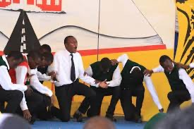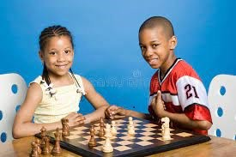Soma mazungumzo yafuatayo kisha ujibu maswali.

(Katiku na Solo wamekutana njiani.)
Solo: Masalkheri Katiku?
Katiku: Akheri Solo. Habari za muda sahibu?
Solo: Njema. (Akiyaangalia mavazi yake.) Umetoka wapi? Katiku: Nimetoka kwenye mazoezi ya mchezo wa kuigiza. Solo: Hakika unapenda drama.
Katiku: Ndiyo. Drama inakuza ubunifu, mawasiliano na ushirikiano. Isitoshe, inaburudisha.
Inaweza pia kukupa kipato maishani.
Solo: Kipato? Kumbe michezo ya kuigiza ina manufaa mengi hivi?
Katiku: Ndiyo, Solo. Si hayo tu. Drama pia hukuza uwezo wa kufikiria kwa kina na kutatua matatizo.
Solo: Aha! Sasa nimepata mwanga zaidi. Asante kwa kunielimisha.
Katiku: Karibu. Nawe unapenda mchezo upi?
Solo: Ninapenda mchezo wa chesi.
Katiku: (Kwa mshangao) Chesi? Nilifikiri ungetaja kandanda, jugwe au hoki ! Solo: (Akitabasamu) Ni mchezo mzuri. Unajua kuwa mchezo huu pia hunoa akili ? Katiku : Aha! Sikuyafahamu hayo. Asante Solo.
Solo: Karibu. Sote tumeelimishana. Hakika elimu ni bahari!
Katiku: Kweli mwandani wangu. Kwaheri!
Solo: Kwaheri ya kuonana. (Wote wanaondoka.)

- Badala ya masalkheri, solo pia angesema, ?
  - hujambo
  - umeamkaje
  - shikamoo
  - salama

- Ni neno lipi la adabu alilotumia Solo katika mazungumzo haya?
  - kumbe
  - hakika
  - asante
  - aha

- Sentensi zifuatazo zimetumiwa katika mazungumzo haya. Ni sentensi ipi inayoonyesha kuwa Katiku anakubaliana na alichosema Solo?
A Nimetoka kwenye mazoezi ya mchezo wa kuigiza.
- Inaweza pia kukupa kipato maishani.
- Drama pia hukuza uwezo wa kufikiria kwa kina
- Kweli mwandani wangu. Kwaheri
- Je, ungeyasikiliza mazungumzo ya Katiku na Solo, ungejifunza nini?

  - Ni sharti ushiriki katika michezo ya kuigiza ili utambulike.
  - Ni muhimu kubadilishana mawazo kuhusu mambo tunayoyajua.
  - Kufikiria kuhusu michezo kunapunguza matatizo.
  - Kufahamu aina zote za mchezo kunamletea mtu fahari.

- Neno lingine ambalo lina maana sawa na sahibu ni:
  - rafiki
  - ndugu
  - jirani
  - binamu

Swali la 6 hadi la 8

Soma kifungu kifuatacho kisha ujibu maswali.

KIJIJI CHA FANAKA
Eneo la Jitegemee limo kaskazini mwa Kaunti ya Kambini. Jitegemee ina vijiji vitano. Fanaka ndicho kijiji kidogo zaidi hapo Jitegemee. Ni kijiji ambacho huwavutia na kuwashangaza wengi.
Wanakijiji wa Fanaka ni wenye bidii ya mchwa. Mtu anapotembelea Fanaka alfajiri hukutana na misafara ya watu ; wake kwa waume, wazee kwa vijana. Wao huwa wanaenda kutafuta riziki. Wapo wanaobeba vibuyu na mitungi, wanaenda kutafuta maji mtoni au kwenye vibanda vya maji. Wengine hubeba majembe kuelekea mashambani. Imani yao huwa, achanikaye kwenye mpini hafi njaa. Wapo wachuuzi wanaosukuma mikokoteni yenye madebe ya maziwa ya kuuza. Wapo wanaoenda kufanya kazi kwenye majengo na viwanda. Wengine wamevaa suti na tai, wanaelekea afisini au shuleni kufundisha. Vilevile, wapo wanafunzi wanaoelekea shuleni na vyuoni. Hakika, kila mja katika kijiji hiki hushughulika.

Bidii ya wakazi wa Fanaka imewawezesha kujitegemea. Fanaka haijawahi kukosa chakula. Japo mvua hainyeshi kila msimu, maghala ya wenyeji huwa yamejaa chakula. Ukiwauliza vipi wanaweza kuwa na chakula kila msimu, wao hukuambia kuwa ukame haumzuii mtu kuilisha familia yake. Wao wamechimba visima vya maji. Wananyunyizia mimea yao maji. Hii ndiyo maana kijiji cha Fanaka kinavipatia vijiji vingine chakula.

- Ni jibu lipi sahihi kulingana na aya ya kwanza?
  - Kaskazini mwa Kaunti ya Kambini mna vijiji vitano.
  - Eneo la Jitegemee ndilo dogo zaidi katika Kaunti ya Kambini.
  - Sehemu nyingi katika Kaunti ya Kambini huwafurahisha wengi.
  - Kaunti ya Kambini husifiwa na wenyeji wengi.

- Kifungu kinaonyesha kwamba wanakijiji wa Fanaka wana bidii kwani:
  - Anayezuru kijiji hicho hukutana na watu wengi.
  - Hakuna yeyote katika kijiji hiki asiyekuwa na kazi ya kufanya.
  - Wanakijiji huendeleza shughuli zao kwa kuaminiana.
  - Watu wanafanya kazi viwandani bila kuona ugumu.

- Kama ungeishi katika kijiji cha Fanaka, ungepata faida gani?
  - Kujenga majengo ya fahari.
  - Kuwauzia wakaazi wa vijiji vingine chakula.
  - Kupata riziki kwa urahisi.
  - Kujifunza ushirikiano katika utendakazi.

Swali la 9 hadi la 12

Soma mazungumzo yafuatayo kisha ujibu maswali.

Adili: (Akimtazama Kasimu) Hujambo kaka? Naona leo umefika mapema mno. Kuna nini?
Kasimu: (Akimwonyesha sare ambayo amevaa) Jamani! Mtu akikusikia atadhani mimi hufika hapa saa tano! Je, umesahau leo ni Ijumaa ?
Adili: Nitasahau vipi na leo ni siku ya gwaride?
Kasimu: Ndiyo, leo kuna gwaride. Unajua kikundi chetu cha wanaskauti ndicho kinachoongoza. Nataka wenzangu wakija wanipate hapa. Tutafanya mazoezi kwanza. Staki aibu.
Adili: Kumbe! Nilikuwa nimesahau kuwa wewe ndiye kiongozi.
Kasimu: Na kiongozi mara zote …
Adili: Huongoza akina Adili wakimfuata.
Kasimu: Adili nawe, huachi utani?
Adili: Utani? Kwani kiongozi hufanya nini? Hukumbuki ulichotuambia Alhamisi?
Kasimu: Alhamisi gani?
Adili: Kwani kuna Alhamisi ngapi? Alhamisi si ni hiyo hiyo moja?
Kasimu: Ndiyo, ni moja, ila ni nyingi tu.

Adili: Kasimu. Huachi kuutia ubongo wangu katika mtihani. Itakuwaje moja na wakati huo huo ziwe nyingi?
Kasimu: Sidhani ni mtihani. Huoni kwamba kila wiki huwa na Alhamisi tofauti na ya wiki nyingine?
Adili: Oh! Kweli. Naona umekuwa kiongozi kweli kweli. Mlezi wangu huniambia kwamba kiongozi sharti awaelimishe anaowaongoza. Naona ukiendelea hivyo tutakuteua kuwa Kiranja Mkuu.
Kasimu: Wakati wa kuwa Kiranja Mkuu utafika. Ila tulikuwa tunazungumzia Alhamisi.
Niliwaambia nini?
Adili: Umesahau? Basi Alhamisi ya mwanzo wa mwezi huu tulikuwa na kikao cha kusoma kitabu kitakatifu huko nyumbani. Wewe ndiye uliyekuwa unaongoza kikao. Ulitusomea aya kuhusu kiongozi mwema. Ulituambia kuwa kiongozi sharti awe mfano mwema kwa wengine. Aidha ulitueleza kwamba kiongozi lazima atekeleze majukumu yake ipasavyo.
Kasimu: Nakumbuka.
Adili: Ni hivyo, mwenzangu. Kiongozi lazima awe mwangalifu siku zote asiwapotoshe wengine. Jitazame ulivyo leo. Sare yako ni nadhifu mno. Je, wenzako kweli watavaa nguo chafu?
Kasimu: Bila shaka watajaribu kuwa nadhifu. Hata naona mmoja wao ndiye huyo. Acha tuwahi mazoezi. Akina Adili wanahitaji kuonyeshwa njia bora ya kupiga saluti. (Anaondoka huku akichekacheka)
Adili: (Akipaza sauti) Haya, haya kiongozi bora. Tuonane baadaye.
- Kwa nini Kasimu alifika shuleni

mapema siku hiyo?
  - Ni mazoea yake kufika mapema kila siku.
  - Ni mwanachama wa kikundi cha wanaskauti.
  - Ilikuwa siku ya gwaride shuleni mwao.
  - Kikundi cha wanaskauti hakipendi aibu.

- ‘‘Mlezi wangu huniambia kwamba kiongozi sharti awaelimishe anaowaongoza.’’
Sentensi hii imetumika katika kifungu kuonyesha kwamba:
  - Wanaoongozwa lazima wawaelekeze wengine.
  - Wazazi wanawafahamu viongozi wote wema.
  - Familia huwashauri watoto kuhusu uongozi.
  - Watoto humtegemea kiongozi kwa kila jambo.
- Fikiria kwamba leo ni Jumatatu. Darasa la akina Kasimu lina kikao cha mjadala kesho kutwa. Je, mjadala utafanywa siku gani?
  - Jumatano
  - Jumanne
  - Alhamisi
  - Ijumaa

- Maana ya tutakuteua kulingana na kifungu ni :
  - tutakuchagua
  - tutakuamini
  - tutakushauri
  - tutakuomba

Soma kifungu kifuatacho kisha ujibu maswali.
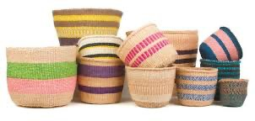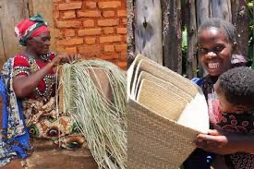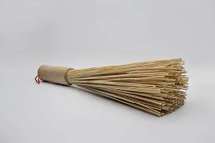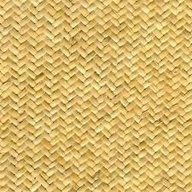
Juma, Maria, Asha, Yohane na Teresia walimtembelea nyanya yao kijijini. Nyanya hutengeneza mikeka, vikapu na fagio. Yeye hutumia vifaa hivi nyumbani na vingine huvipeleka sokoni kuviuza.
Vijana hawa walimsaidia nyanya yao katika shughuli hiyo. Juma, Maria na Teresia walifuma mikeka. Maria, Yohane na Teresia walitengeneza fagio. Wote, isipokuwa Juma na Teresia walifuma vikapu. Wavulana wote walileta vifaa vya kufanyia kazi. Baada ya kumaliza kazi, vijana wote isipokuwa Asha walifagia eneo walilofanyia kazi. Vijana wote isipokuwa Maria walimsaidia nyanya kupeleka bidhaa walizotengeneza sokoni.

- Ni kijana yupi alitengeneza vifaa vitatu?
  - Asha
  - Yohane
  - Maria
  - Juma

- Ni nani hakumsaidia nyanya kupeleka bidhaa sokoni?
  - Teresia
  - Maria
  - Yohane
  - Juma

- Kulingana na kifungu:
  - Yohane, Maria na Asha walifuma vikapu.
  - Teresia, Yohane na Juma walifuma mikeka.
  - Asha, Maria na Teresia walifuma mikeka.
  - Juma, Maria na Yohane walifuma vikapu.

Soma kifungu kifuatacho. Kwa kila swali umepewa majibu manne. Chagua jibu lifaalo zaidi
kati ya yale uliyopewa.
Kedi aliishi katika nyumba 16 . Kwenye sakafu 17 nyumba hiyo kulikuwa na 18 maridadi. Pia kulikuwa na makochi ya kukalia. Vitu hivi viliifanya nyumba 19 . Kila siku Kedi 20 kupiga deki sakafu ili kuondoa vumbi.

16. A. nzuri | B. kuzuri | C. vizuri | D. mzuri
17. A. kwa | B. mwa | C. ya | D. la
18. A. fremu | B. pazia | C. kizingiti | D. zulia
19. A. kupendea | B. kupendeza | C. kupendezwa | D. kupendezana
20. A. amefurahia | B. atafurahia | C. alifurahia | D. akifurahia

Swali la 21 hadi la 30
Chagua jibu sahihi.
- Hii ni picha ya kifaa cha nyumbani.

Chagua sauti zinazokamilisha jina la kifaa hicho.

b_l_uri
  - i, a
  - u, i
  - o, a
  - e, i

- Hili ni jedwali la maneno. Chagua jibu linaloonyesha vitendo?

- Maneno haya yanavyofuatana vipi katika kamusi?
- pera
- papai
- pesheni
- parachichi

A. (iv), (i), (iii), (ii)
B. (ii), (iv), (i) (iii)
C. (iv), (iii), (ii), (i)
D. (ii), (i), (iv), (iii)

- Yafuatayo ni majina ya vifaa vinavyopatikana shuleni. Ni yapi yaliyo katika ngeli moja?
  - rula, chati, bendera
  - kalamu, uwanja, kabati
  - ubao, rafu, mlingoti
A | pika | nunua | saidia
B | heshima | sahani | kifutio
C | bora | tulivu | nyingi
D | haraka | kabisa | sana

  - wino, dawati, penseli

- Chagua jibu ambalo ni wingi wa sentensi:
Mkoba wa mwanafunzi una kitabu.
  - Mikoba ya mwanafunzi ina kitabu.
  - Mikoba ya wanafunzi ina vitabu.
  - Mikoba ya wanafunzi ina kitabu.
  - Mikoba ya mwanafunzi ina vitabu.

- Chagua jibu ambalo lina maneno ambayo ni kinyume.
  - mgeni – mwenyeji
  - mzazi – mlezi
  - nyanya – ajuza
  - kaka – ndugu

- Chagua jibu linalounganisha sentensi hizi kwa usahihi.
- Tina alimpikia Saimo chai.
- Saimo alimpikia Tina chai.

- Saimo alipikiwa chai kwa Tina.
- Tina alipikia chai kwa Saimo.
- Tina na Saimo walipikiana chai.
- Saimo na Tina walipikiwa chai.
- Chagua sentensi ambayo ni ukanusho wa:
Wachezaji wataimba wimbo wa taifa.
  - Wachezaji hawakuimba wimbo wa taifa.
  - Wachezaji hawangeimba wimbo wa taifa.
  - Wachezaji hawajaimba wimbo wa taifa.
  - Wachezaji hawataimba wimbo wa taifa

- Ni sentensi ipi iliyo katika hali ya udogo?
  - Kijito hicho kina maji safi.
  - Kiwiko cha mkono wake
kimepona.
  - Kiberiti kimenunuliwa na mama.
  - Kiota cha ndege kinavutia.

- Chagua jibu lenye maana sahihi ya nahau.
  - piga hatua – angalia mbele ili usianguke.
  - piga hodi – subiri mlangoni ili kufunguliwa.
  - fanya haki – kumpa mtu anachostahili kupata
  - fanya bidii – endelea na shughuli fulani kwa kasi.

HUU NDIO UKURASA WA MWISHO ULIOPIGWA CHAPA.

THE KENYA NATIONAL EXAMINATIONS COUNCIL
Kenya Primary School Education Assessment

INTEGRATED SCIENCE

1 hour 40 minutes
INSTRUCTIONS TO CANDIDATES (Please read these instructions carefully)

- You have been given this question booklet and a separate answer sheet. The question booklet contains 50 questions.
- Do any necessary rough work in this booklet.
- When you have chosen your answer, mark it on the ANSWER SHEET, not in this question booklet.

HOW TO USE THE ANSWER SHEET
- Use an ordinary pencil.
- Confirm that the answer sheet that you have been provided with the following:
YOUR ASSESSMENT NUMBER YOUR NAME
NAME OF YOUR SCHOOL NAME OF SUBJECT
- Do not make any marks outside the boxes.

- Keep the sheet as clean as possible and do not fold it.

- For each of the questions 1 – 50, four choices are given. The choices are lettered A, B, C and D. In each case, only
ONE of the four choices is correct. Choose the correct answer from the choices.

- On the answer sheet, the correct answer is to be shown by drawing a dark line inside the box in which the letter you have chosen is written.

Example
In the Question Booklet:

  - John and Peter observed a mango fruit falling from a mango tree. John told Peter that the mango fell because of
    - high temperature
    - force of gravity
    - its small mass
    - its high motion The correct answer is B.
On the Answer Sheet:
In the set of boxes numbered 11, draw a dark line inside the box with the letter B printed in it as indicated below.
11 [A] [B] [C] [D]

- Your dark line MUST be within the box.

- For each question, ONLY ONE box is to be marked in each set of four boxes.

This question paper consists of 10 printed pages

© 2022 The Kenya National Examinations Council

- During a nature walk learners observed some maize plants in the school garden having weak stems and yellowing leaves. They decided to apply some manure around the roots. After a week, the stems became strong and leaves turned green. This demonstrates that maize as living things
  - reproduce
  - breathe
  - feed
  - grow

- The diagram represents some parts of the human digestive system.
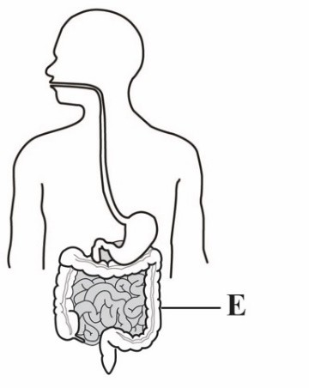
Which one of the following is the main function of the part labeled E in digestion?
  - Absorption of water
  - Storage of undigested food
  - Absorption of digested food
  - Production of digestive juices

- Learners visited a hospital and observed a patient whose backbone was broken following a road accident. The patient was not able to walk. Which two functions of the backbone were impaired?
  - support and production of red blood cells.
  - balance and storage of fat.
  - balance and protection of inner parts.
  - support and protection of inner parts.

- During a class discussion learners stated the following as functions of sense organs in human beings:

- Heat reception
- Light reception
- Touch
- Taste

Which two are functions of the skin?

  - (i) and (ii)
  - (i) and (iii)
  - (ii) and (iii)
  - (ii) and (iv)

- The diagram represents some parts of the human breathing system.
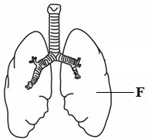

Which two are functions of the part labelled F?

  - cleaning and absorbing air
  - receiving oxygen and cleaning it up
  - receiving oxygen and releasing carbon dioxide
  - moistening and warming air.

- While sweeping the classroom, Jane felt some irritation in her eyes. Which one of the following is most likely to have caused the irritation?

  - light
  - dust particles
  - cold weather
  - bad smell

- John collected clear water from a river and stored it in a pot. This water can be made safe for drinking by

  - boiling it
  - cooling it
  - covering the pot
  - sieving it

- Juma intended to clean a pit latrine. What safety precautions should he take while cleaning the pit latrine? Wear
  - rubber gloves, shoes and goggles
  - overcoat, shoes and face mask
  - goggles, face mask and rubber gloves
  - face mask, rubber gloves and shoes.

- The diagram shows a word puzzle in which words can be formed vertically, horizontally or diagonally.

I | M | A | G | E
C | P | U | S | L
A | C | U | P | B
C | O | D | E | A
M | E | A | N | C

Which of the following words can be formed from the puzzle?
  - MONITOR
  - DRIVE
  - MOUSE
  - KEYS
- During a Science and Technology lesson, learners stated the following as functions of parts of a computer:
- Displaying information
- Processing information
- Controlling the working of all parts of a computer
- Entering data
Which two are functions of a Central Processing Unit (CPU) as part of a computer?
  - (i) and (ii)
  - (ii) and (iii)
  - (i) and (iv)
  - (iii) and (iv)
- The diagram represents a set-up that was used by learners to investigate a characteristic of gases.

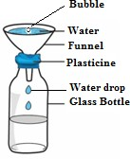
Learners observed bubbles as water entered the bottle. The characteristic being investigated is that gases

  - occupy space
  - have indefinite shape
  - have mass
  - increase in size

- Learners placed a bottle top in water and it floated. When they crushed it and placed it in the same water it sunk. Which one of the following factors affected the floating or sinking of the bottle top?
  - Size of the bottle top.
  - Type of material of the bottle top.
  - Mass of the bottle top.
  - Shape of the bottle top.

- The picture shows a learner demonstrating a certain effect of force on an object.
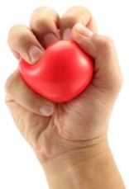
The demonstration shows that force

  - changes direction of an object
  - makes an object to start moving
  - changes shape of an object
  - makes an object to stop moving

- The diagram below shows a learner using a lit candle to demonstrate that light travels in a straight line.
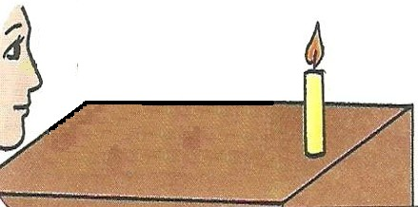
Which one of the following materials would be suitable for the demonstration?
  - a flexible tube
  - a clear glass
  - an oiled paper
  - water in a glass.
- The diagram below represents a spade in use with parts labelled G, H, J and K.
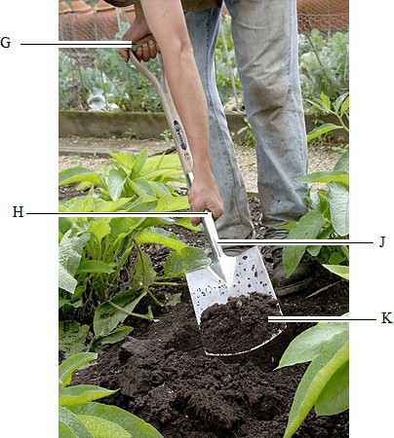

The effort is at position

  - G
  - H
  - J
  - K

- Grade Five learners toured the school compound and identified a place full of soil deposited by flowing rain water. How can the learners recover the deposited soil?

  - Collect and use it for modelling.
  - Collect and use it for growing crops.
  - Collect and use it for constructing houses.
  - Plant crops on the deposited soil.

- Grade Four learners visited a neighbouring farm and observed different uses of water. Which one of the following is an agricultural use of water they observed?

  - Washing clothes and shoes.
  - Watering plants and animals.
  - Cooking food.
  - Cleaning the toilet.

- During a heavy rainfall season, learners observed that beans planted in clay soil had turned yellow. This is because clay soil

  - was holding a lot of water.
  - had lost most of the water.
  - had no water.
  - had become sticky.

- Grade Four learners placed the structure labelled E on the school maize farm.
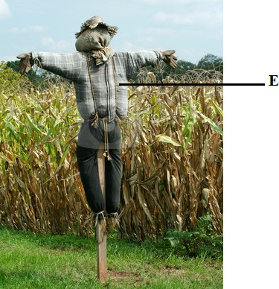
This was to

  - attract cattle to the farm
  - make the farm attractive to children
  - scare birds away from the farm
  - control weeds on the farm.
- Learners planted fruit trees and were asked to take care of them. Which is the most appropriate method of watering they can use during the dry season? Using

  - drip bottles
  - jerricans
  - furrows
  - buckets.

- A farmer keeps cattle, sheep and goats. The animals provide the farmer with meat and
  - manure
  - security
  - companionship
  - beauty

Ali intends to establish a nursery bed for the tree tomato plants shown below using container gardens. Study the picture and use it to answer questions 22 to 25.

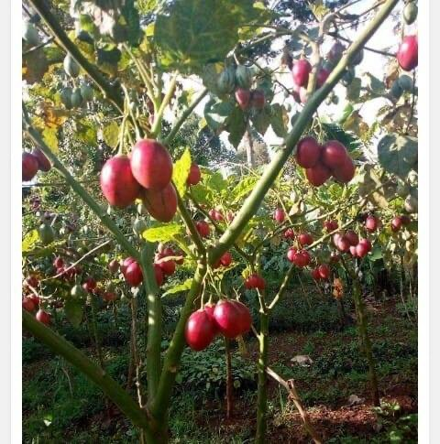

- Which one of the following planting materials should Ali use to establish the nursery bed?

  - Stem cuttings.
  - Seeds.
  - Splits.
  - Suckers.

- Which one of the following statements correctly describes how Ali should prepare the planting materials?

  - Cut and clean the stem cuttings.
  - Pluck out the splits from the stem.
  - Extract seeds from the fruit and dry.
  - Dig out the suckers and clean.

- After establishing the nursery bed, which tree tomato seedlings should Ali transplant?
  - Seedlings with few pests.
  - Small seedlings.
  - Seedlings with 3 leaves.
  - Strong seedlings.

- How best can Ali encourage the community members to grow the tree tomato crop?

  - Advertise tree tomato fruits.
  - Give them free tree tomato fruits.
  - Sell them tree tomato fruits.
  - Sell them tree tomato seedlings.

- Patel is preparing to attend a birthday party of his friend who is turning ten years old. He is ironing the clothes he will wear. Which of the following is the best reason why he is ironing his clothes?

  - To look smart
  - To feel warm
  - To dry the clothes
  - To remove bad smell
- Mbira wants to buy shoes for his pre-teen son Renja. Which one of the following is a factor Mbira should consider when buying the shoes?

  - Age of Mbira
  - Time of the day
  - Size of the shop
  - The occasion

- Schools were finally opening after the long Covid-19 break. Mr. Kamau asked each of his children to write a shopping list of the items they needed for school. Read what each one of them wrote:

Marygoretty: 3 bar soap, 20 masks,
4 pens.

Rose: bar soap, masks, pens.

Paul: 3 bar soap @ 80, 20 masks @10,
3 pens @ 20.

Who among the children wrote a complete shopping list?

    - Rose
    - Paul
    - Marygoretty
    - Paul and Rose

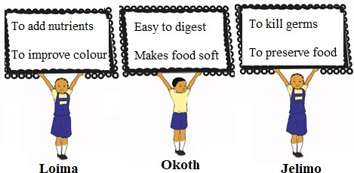
29.
Loima, Okoth and Jelimo made the posters below.
Which learners made posters showing reasons why we boil food?
A.
B.
C.
D.
Loima, Okoth, Jelimo Loima and Okoth Loima and Jelimo Okoth and Jelimo
30.
Grade Four learners were given various foods to classify. They classified them as follows:

Group 1: mangoes, oranges, kales,
Spinach

Group 2: potatoes, maize, rice, yams Group 3: meat, chicken, fish, beans Group 4: meat, rice, ugali, milk
Which group consists of protective foods?
- Group 1
- Group 2
- Group 3
- Group 4
- Khadija’s mother always preserves the excess milk she gets from her dairy cow for other uses. Which of the following is a reason why she preserves the milk?
  - To increase the amount of milk
  - Make the milk easy to transport
  - To avoid milking the cow again.
  - To avoid feeding the cow always

- Peter has finished taking water using a glass. He wants to clean the glass using a soft cloth. Which of the following is a reason why he should use a soft cloth to clean the glass?
  - To avoid breaking the glass.
  - To make the glass shine.
C. The soft cloth is easily
available.
D. To avoid scratching the glass.

Read the story below and use it to answer questions 33 and 34

When hanging his shirt on the clothes line to dry, Musa realized that the shirt had two missing buttons. He decided to go and buy the buttons to fix on his shirt later.

- Which group of needlework tools will Musa need to fix the missing buttons?
  - Pins, pin cushion, thread, ruler
  - Scissors, needle, thimble, pins
  - Needle, thread, thimble, scissors
  - Thread, thimble, pins, ruler

- Which of the following would be the first step Musa will do when threading the needle to fix the buttons?

  - Put the thread through the eye of the needle.
  - Cut a piece of thread using an appropriate tool.
  - Pull the thread through the eye of the needle.
  - Hold the needle between the thumb and the index finger.

- The diagram below shows a jerrican that Lucy wants to use to improvise washing equipment.
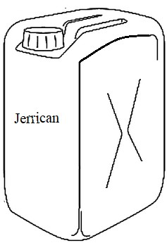
Which washing equipment listed below can Lucy improvise using the Jerrican?

  - Pegs, water tank, drying rack.
  - Basin, bucket, laundry basket.
  - Scrubbing brush, clothesline.
  - Drying rack, water tank, pegs.

- Learners matched various equipment with the games and sports they are used to play as follows:
- Ball for netball
- Bat for soccer
- Rope for tug of war
- Relay button for volley ball
Which of the following represents a combination that was correctly matched?
- (i) and (ii)
- (ii) and (iii)
- (i) and (iii)
- (iii) and (iv)
- Why should a soccer game for learners in Grade Six be made enjoyable?

  - So that bystanders can keep watching the game.
  - Make learners play more to acquire skills.
  - Keep learners busy outside their class.
  - To make learners avoid other games.

- When playing ball Games, team mates pass the ball to each other using various types of passes. Look at the following images and identify an overarm pass.

  - B.

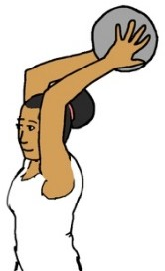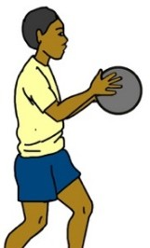

C. D.
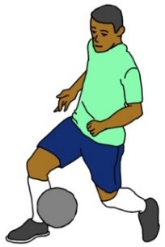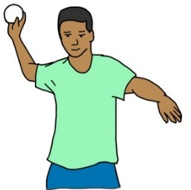

- You have been tasked by your team members to improvise a relay race baton. Which group of items would be appropriate for you to use?

  - Manilla Papers, Nails, Glue
  - Manilla Papers, Glue, Scissors
  - Manilla Papers, Timber Glue
  - Manilla Papers, Timber, Nails

- What action is taken against a player who does not respect the rules of a soccer game?

  - The player’s position is changed.
  - The player is made the goalkeeper
  - The player is removed from the game
  - The player is made to run around the field.

- Identify the parts of the body that supports a gymnast when performing a headstand.
  - Head and shoulders
  - Head and toes
  - Hands and knees
  - Hands and forehead

- Why should you wear gloves when handling a classmate who is nose bleeding?

  - To make the hands look smart.
  - To avoid infections
  - To keep the hands warm
  - Fear of seeing blood

- During the inter-school games one of the players hurt his knee and required first aid. Which of the following is not a reason for providing first aid to the injured player?

  - To save lives of the injured player.
  - To prevent the injury from getting worse.
  - To receive payment for assisting the player.
  - To help the injured player recover faster.
- After two minutes of play, Anita complained of severe pain in her ankle. Which of the following could be the cause of the pain?
  - She did not drink enough water before the game.
  - She had eaten a lot of food before getting into the game.
  - She did not have her shoes on during the game.
  - She had not warmed up before getting into the game.

- The images below show human body organs. Which one of the organs is used for pumping blood during a warm up activity?

  - B.
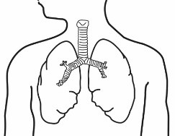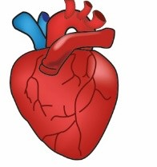

C. D.
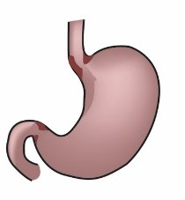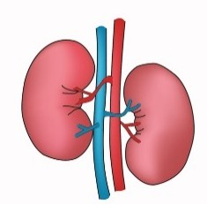

- A player was disqualified from the school team for being involved in drugs and substances abuse. Which group of substances below is the player likely to have used?

  - Alcohol, glue, and milk
  - Glue, water, and bhang
  - Glue, alcohol, and bhang
  - Bhang, milk, and alcohol

- Grade Six teacher guided the class to perform the activity shown in the image below. Which component of physical fitness was developed in learners?
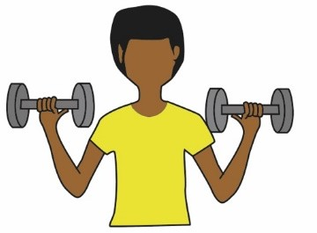
  - Balance
  - Reaction time
  - Speed
  - Strength

- The picture below shows a
technique in athletics.
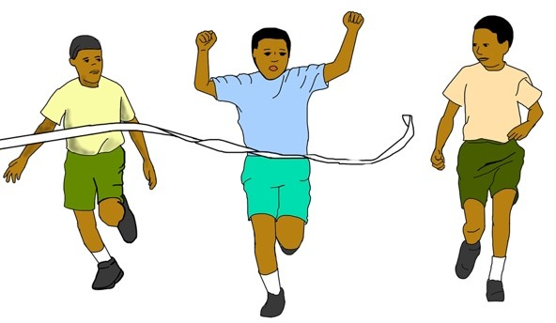
  - Waist sprint finish
  - Run through finish
  - Drop finish
  - Chest front finish
- Identify the image that shows an athlete clearing a hurdle.

  - B.
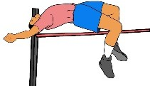
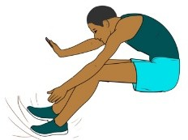

C. D.
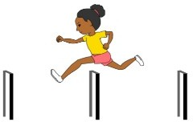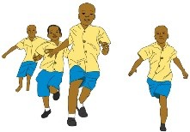

- During an inter-class athletics competition, a teacher can use a
to start off athletes in a race.

  - Sound ball
  - Relay buttons
  - Starting blocks
  - Clappers

THE KENYA NATIONAL EXAMINATIONS COUNCIL
Kenya Primary School Education Assessment

CREATIVE ARTS AND SOCIAL STUDIES

Grade 6
1 hour 40 minutes
INSTRUCTIONS TO CANDIDATES (Please read these instructions carefully)

- You have been given this question booklet and a separate answer sheet. The question booklet contains 50 questions divided into two parts: Part I and Part II. Answer all the questions in part I. In part II there are three sections. Choose the section that you have prepared for and answer all the questions.
- Do any necessary rough work in this booklet.
- When you have chosen your answer, mark it on the ANSWER SHEET, not in this question booklet.

HOW TO USE THE ANSWER SHEET
- Use an ordinary pencil.
- Confirm that the answer sheet that you have been provided with has the following:
YOUR ASSESSMENT NUMBER YOUR NAME
NAME OF YOUR SCHOOL NAME OF SUBJECT
- Do not make any marks outside the boxes.
- Keep the sheet as clean as possible and do not fold it.
- For each of the questions 1 – 50, four choices are given. The choices are lettered A, B, C and D. In each case, only
ONE of the four choices is correct. Choose the correct answer from the choices.
- On the answer sheet, the correct answer is to be shown by drawing a dark line inside the box in which the letter you have chosen is written.

Example
In the Question Booklet:

23. One way in which your school can collaborate with the neighbouring community is by

A. producing good results B. cleaning the market in the neighbourhood
C. maintaining discipline D. planting of trees in the school compound The correct answer is “B”.
On the answer sheet.
In the set of boxes numbered 23, draw a dark line inside the box with the letter B printed in it as indicated below.
23 [A] [B] [C] [D]

- Your dark line MUST be within the box.
- For each question, ONLY ONE box is to be marked in each set of four boxes.

This question paper consists of 14 printed pages
©2022 The Kenya National Examinations Council

PART I

  - The picture below was drawn from observation:

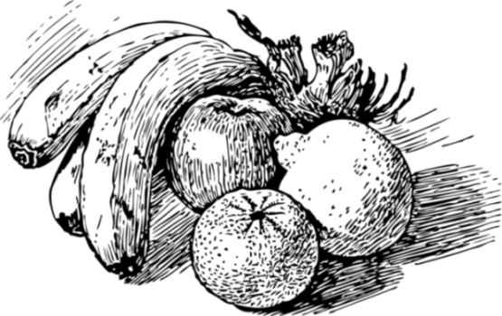
Choose two art elements used in the picture.
    - Line and texture.
    - Space and value.
    - Balance and line.
    - Colour and shape

  - Grade Five learners were discussing their artworks and discovered some of the objects had different shapes and sizes.
Identify the principle of art that relates to different shapes and sizes.
    - Balance.
    - Proportion.
    - Symmetry.
    - Rhythm.

  - The picture below shows a value gradation strip. Arrange the gradation in correct order from light to dark.

i ii iii iv

- ii, iii, i, iv.
- ii, iv, i iii.
- iii, i, iv, ii.
- iv, ii, iii, i.
  - The pictorial composition below was made using crayon etching technique:
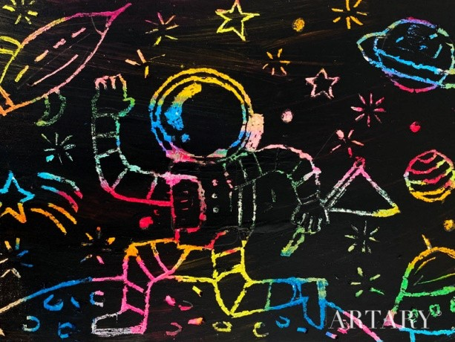
© 2021 ARTARY Academy of Children's Art.

What was the last step in completing the process?
    - Drying the artwork.
    - Applying black ink.
    - Scratching with a sharp tool.
    - Applying coloured waxy crayons.
  - A group of learners cleaned up after modelling with clay. Which of the following is not a reason for cleaning up?
    - To avoid making surfaces dirty.
    - To keep clean and healthy.
    - To make hands sticky.
    - To prevent diseases.

  - You are to reuse leather for a class assignment. Which one of the following is not recycled leather?
    - Old belts.
    - Old bags.
    - Torn shoes.
    - Animal hides.

  - 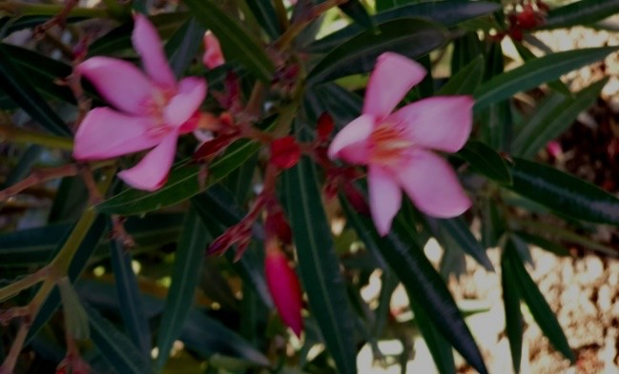During a tie and dye practical session, Oma dipped a yellow tee shirt in blue dye. How did the blue dye affect the colour of the tee shirt?
    - There was no change in colour.
    - Colour changed to purple.
    - Colour changed to green.
    - Colour faded.

  - Nala took the photograph shown below:

Identify the elements of photography that Nala needs to improve on.
    - Focus and lighting.
    - Focus and Placement
    - View point and lighting.
    - Lighting and background.

  - Your school drama club is to present a play using a rod puppet.
Which of the following is not the correct way of moving a puppet during a presentation?
    - Put the rod puppet on the side while talking.
    - Move the rod puppet sideways while talking.
    - Talk and smile while moving the rod puppet.
    - Move the rod puppet up and down while talking.
  - A learner created the artwork below and framed it using matting technique.

Arrange the following steps in the
correct order of framing the artwork.

- Measure.
- Stick the artwork.
- Cut out the mat.
- Trim the artwork.

  - ii, iv, iii, i
  - i, iii, iv, ii
  - iv, ii, iii, i
  - iii, iv, i, ii.

  - Why is the East African Community (EAC) Anthem performed?
    - For entertainment in the EAC
    - To address issues affecting the EAC
    - To bring unity among the people in the EAC
    - To promote culture in the EAC

Below is a picture of a percussion instrument. Refer to it to answer question 12 and 13.

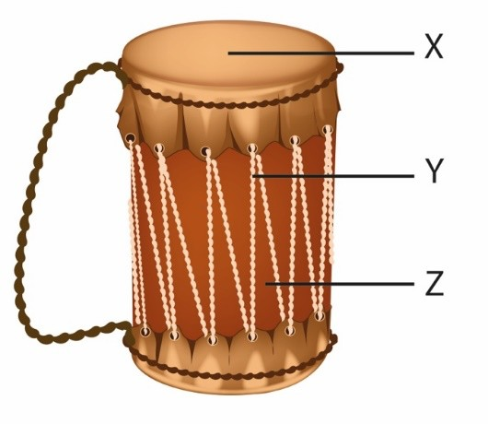
  - The parts labelled X, Y and Z are:

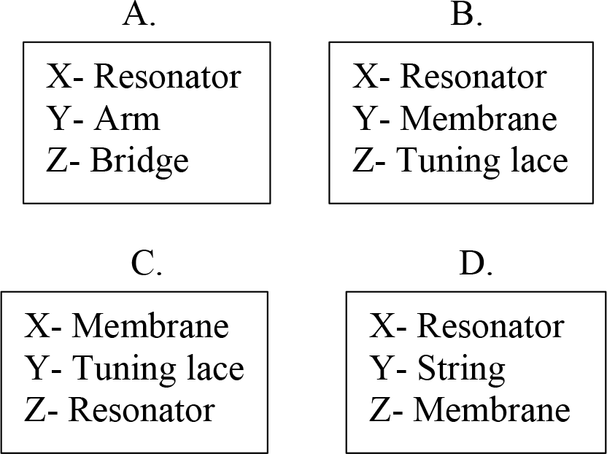
  - Which materials can be used to make the instrument above?
    - Hollow wood, animal skin, strings
    - Hollow wood, piece of cloth, strings
    - Hollow wood, animal skin, metal rod
    - Hollow wood, piece of cloth, animal skin

  - Kipkurui performed a tune using sol-fa
hand signs as shown below:

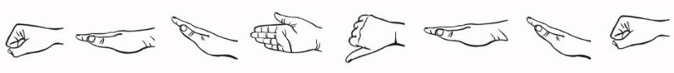
Which solfa syllables represent the tune performed by Kipkurui?
    - m d r s f d r m
    - d m r s f s m d
    - d m r s f m r d
    - m d r s f m r d
  - Mary played six notes on a descant recorder using the fingering and French rhythm indicated in the diagrams below

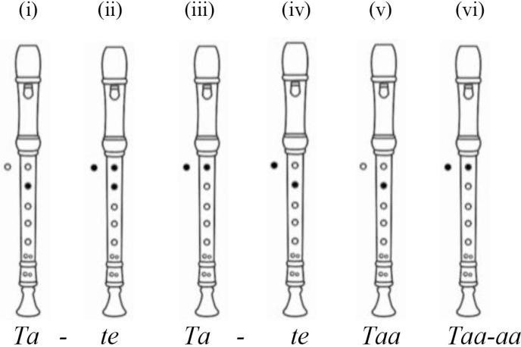
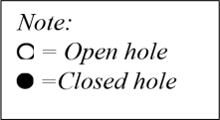

Which tune did she play?

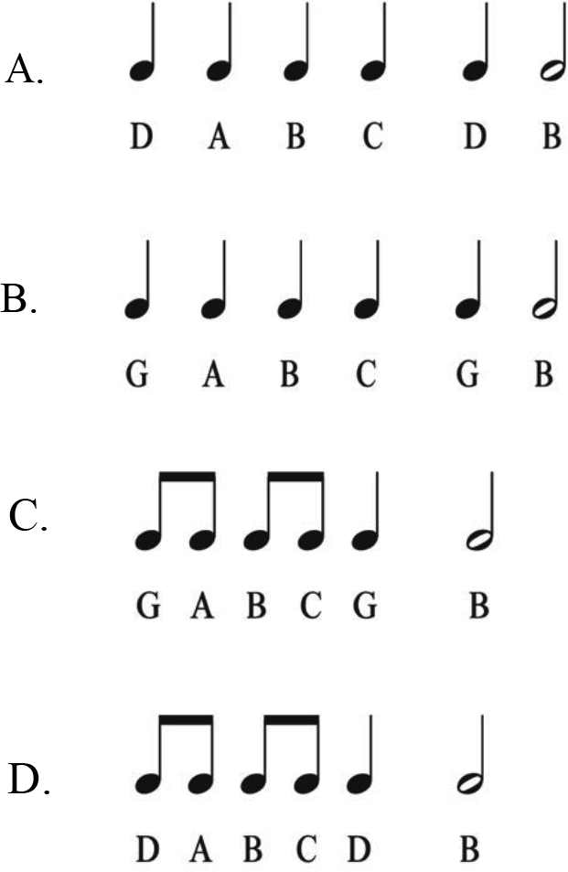

  - Study melodies (i) and (ii) below and answer the question that follows.

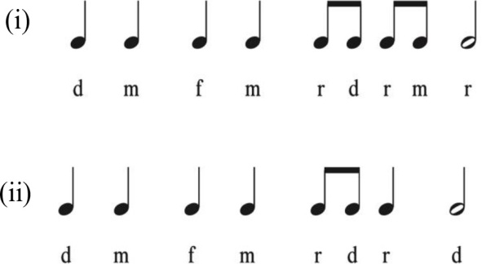

Which statement is true about these melodies?
    - The Melodies have similar rhythms
    - The note at the end of each of the melodies is a crotchet
    - The first four notes are similar in pitch and rhythm
    - The melodies have a similar pitch and rhythm

  - John heard his mother singing to soothe his little brother to sleep. Which sentence below best describes how his mother sang?
    - Fast and soft
    - Slow and soft
    - Fast and loud
    - Slow and loud

  - Which musical term describes loudness and softness of a song?
    - Tempo
    - Dynamics
    - Pitch
    - Structure

  - Rewrite the following French rhythm using note symbols:
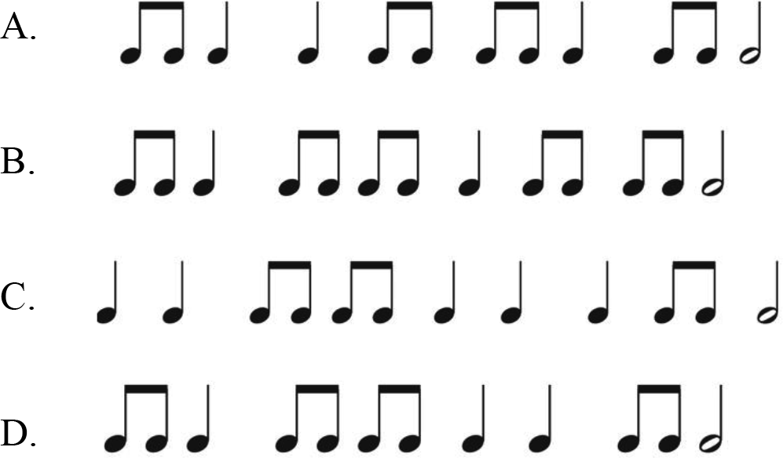
Ta-te taa ta-te ta-te taa taa ta-te taa-aa
  - Which of the note symbols below is correctly matched with its corresponding rest?
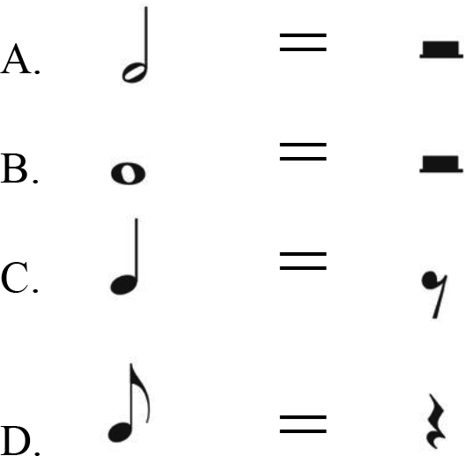

  - James, a new pupil, has joined Kila School. After entering the gate he came across the sign post below.

Church
Garden
Offices
Classes
Which direction will he follow in order to go to the offices?

    - West.
    - North East.
    - East.
    - South West.

The diagram below shows activities in a village. Use it to answer question 22 and 23.

Chief’s office
Church
school
Village
Health Centre
Tea farm
  - Which one of the activities in the village above is an economic activity?

    - Health post.
    - Church.
    - Chief’s office.
    - Tea farm.
  - The administrative activity in the village is shown by the presence of the
    - Church
    - Water point
    - Health centre
    - Chief’s office.

  - Grade Five pupils made a chart with the following characteristics of a climate found in Kenya.
It has two rainy seasons.
It has moderate temperatures. It receives high rainfall.
It has high humidity.

The type of climate described is

    - desert
    - semi desert
    - modified equatorial
    - sub-tropical.

  - The language group that migrated from Southern Sudan through the Nile Valley and settled around the eastern shores of Lake Victoria in Kenya is called

    - River Lake Nilotes
    - Western Bantu
    - Highland Nilotes
    - Plain Nilotes.

  - Which of the traditional cultural activities below are not encouraged by children rights.

    - Education
    - Circumcision
    - Naming ceremonies
    - Early marriage

  - Which is the best way to conserve the Historic built environments?

    - Following laws and regulations.
    - Protecting them from destruction.
    - Repairing the damaged.
    - Involving the Community

  - Which one of the following lakes is not found within the Rift Valley of Kenya?

    - Lake Elementaita
    - Lake Paradise
    - Lake Kanyamboli
    - Lake Nkunga

  - Lake Victoria is important to the economy of Kenya mainly because it
    - uses idle land
    - conserves the environment
    - provides employment
    - provides security

  - James a traditional blacksmith is teaching Ali how to make iron tools. The method he uses is called

    - Storytelling.
    - Apprenticeship
    - Wise sayings.
    - Formal education.

  - Phillip, a Grade Four learner, came across the road sign below at a junction. The sign turned red. What action should he take?
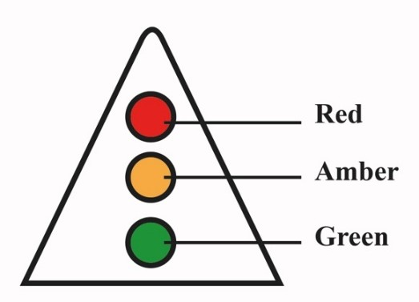

    - Look right and left, then cross the road.
    - Cross the road using the pedestrian walk.
    - Observe how the people are crossing the road and cross
    - Stop and wait for the sign to turn green, then cross.
Use the picture below to answer question 32.
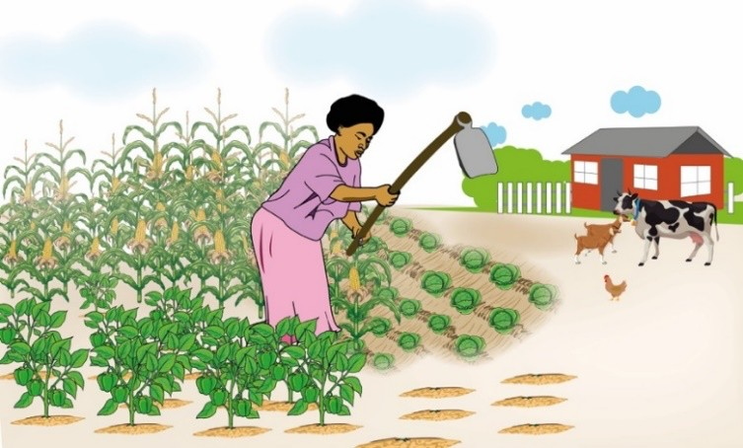

  - The method of farming practised by the farmer in the picture above is known as
    - Subsistence farming
    - large scale farming
    - Dairy farming
    - Horticulture farming

  - Juma, a businessman, is planning to transport fresh fish from Kisumu to sell in Mombasa. Which is the fastest form of transport for him to use?
    - Road
    - Railway
    - Air
    - Water

  - Grade Five learners were asked to make a poster with communication messages to advertise an economic activity practised in Kenya.
- Beaches in Kenya are sandy and clean.
- Welcome to Kenya, the home of Rhinos”.
- Fishing in the ocean makes Kenya rich.
- Kenya has rich cultural heritage.
- Horticulture makes Kenya famous.
Which one of the following group of messages will promote tourism?

A. (i) (ii) (v).
- (ii) (iii) (iv).
- (i) (iii) (v).
- (i) (ii) (iv).

  - Jane did not clean the classroom because she came late to school. Which qualities of a good citizen is Jane lacking?

    - Responsibility.
    - Kindness.
    - Caring.
    - Honesty.

PART II
SECTION A: CHRISTIAN RELIGIOUS EDUCATION

  - Grade Four learners were divided into groups to read and discuss the teachings from the Biblical story of creation. From their discussions, they found out that human beings are considered special because they
A were fearfully and wonderfully made.
- were created in the image and likeness of God.
- were given clothes by God made from skins.
- named all the animals that were created by God.
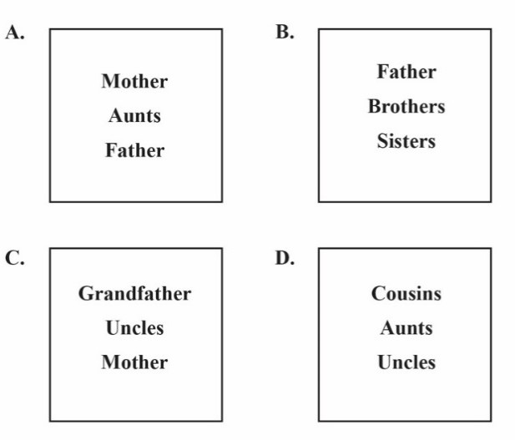
  - Choose the box which only contains members of an extended family.
  - Grade Five learners were given homework to look for information on the fall of human beings according to Genesis Chapter three. They found out that Adam and Eve hid themselves from God because they had
    - made garments from the leaves.
    - disobeyed God’s instructions
    - not cultivated the Garden of Eden.
    - talked to the snake in the Garden of Eden.

  - Your friends in Grade Six tell you that they would like to leave school in order to do the following work:

- Aden said he will go to a construction site to carry stones to get money.
- Monica said that she will go to work as a house girl.
- Terence said he will go and sell foodstuffs in the market.
- Brenda said she will be washing clothes for people to get money.

As a Christian, what advice would you give to your friends?

  - Go to work but share the money with you.
  - Help you also to get work to do.
  - Finish their studies first then look for a job.
  - Go and work but very far from school.

  - The diagram below illustrates various books of the Bible

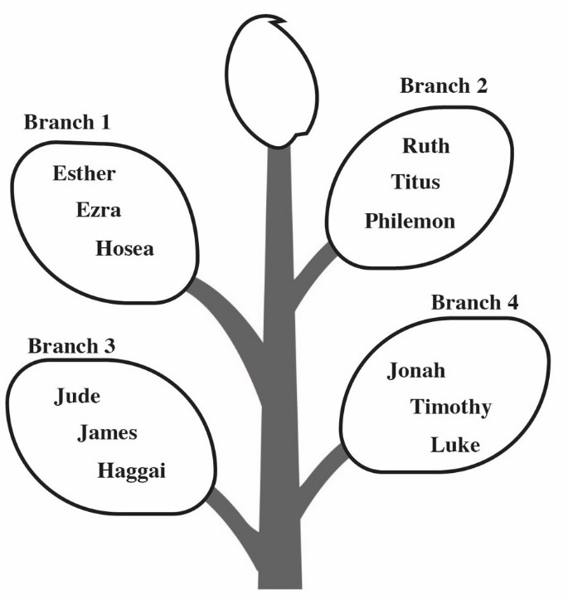

Which branch only contains the books of the Old Testament?
    - Branch 1.
    - Branch 2.
    - Branch 3.
    - Branch 4.

  - You have gone to attend a wedding ceremony with your parents and have been offered a chair to sit on. As the ceremony continues, many other guests arrive who are elderly, yet there are no extra chairs. What is the correct action for you to take?
    - Offer your chair to one of the elderly guests.
    - Look at the elderly guests with a lot of sympathy.
    - Tell the usher to look for other seats.
    - Tell your parents that the place is full of guests.
  - Some Sunday school children went to church and found that their teacher had not arrived. As they were waiting, they did the following activities:
Paul Touched the music
instruments and tried to switch them on.
Sally Started playing inside the
church.
Aaron -- Started wiping the dust off the benches.
Gladys-- Started reading and making comments on the notice board.
Who among the above children showed respect to the house of God?
    - Paul.
    - Sally.
    - Aaron.
    - Gladys.

  - From the story of Nicodemus encounter with Jesus, the requirement that one has to follow in order to enter into the kingdom of God is to
    - give offering to God.
    - give up everything and follow Jesus.
    - visit religious leaders.
    - be born again.

  - A Grade Four teacher asked learners to give the lessons they learnt from the miracle of Jesus healing the ten lepers. The learners gave the following responses:
Ellen seek help when in trouble.
Paul serve others willingly.
Kevin be thankful in their lives.
Grace cooperate with others.
Who among the above learners gave the correct lesson?
    - Ellen.
    - Paul.
    - Kevin.
    - Grace.

  - The following learners were asked how blind Bartimaeus was able to see. They gave the following answers:

Andrew--- by obeying the crowd
who told him to be quiet.
Joyce---- by seeking help from Jesus.
Jayden by sitting and begging on
the road.
Elsie by following Jesus through the towns.
Who among the four learners gave the
correct answer?

    - Andrew
    - Joyce
    - Jayden
    - Elsie

  - Which one of the following pots contains only the fruit of the Holy Spirit?
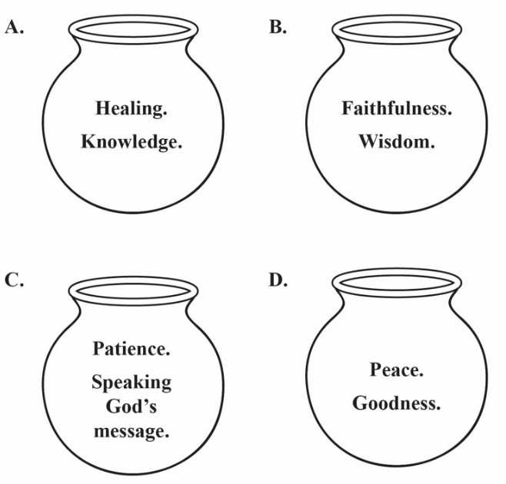

  - Every time Grade Five learners forget their books outside, Albert picks them and returns to the bookshelf. The value Albert demonstrates is
    - responsibility.
    - obedience.
    - kindness.
    - courage.
  - Sharon was requested by her mother to clean utensils after eating food but she did not. The value that Sharon lacked is

    - love.
    - patriotism.
    - obedience.
    - integrity.

  - Which one of the following activities help to promote a healthy boy-girl relationship during adolescence?
    - Attending parties away from home.
    - Playing ballgames together in the field.
    - Exchanging gifts to express love.
    - Meeting each other in lonely place.

  - Your class teacher has realised that most learners use the mobile phones of their parents while at home. The correct advice for the teacher to give learners on how to use a mobile phone is

    - exchanging text messages about their friends.
    - making calls to the friends of their parents.
    - looking for relevant information for your class work.
    - carry the phone to school to watch videos with friends.

SECTION B: ISLAMIC RELIGIOUS EDUCATION
- Grade Four learners were given an assignment to search online for verses from different Surahs and came across a verse that states “and you see that people enter Allah’s religion in crowds”.
The verse is from Surah
  - An-Nas.
  - An-Nasr.
  - Al-Fil.
  - Al-Falaq.
- Amina fears darkness and is unable to sleep well at night.
The two Surah she should recite to seek protection from Allah is
  - Al-Falaq and Al-Ikhlas.
  - Al-Falaq and Al-Fatiha.
  - An-Nas and Al-Ikhlas.
  - An-Nas and Al-Falaq.
- Naima was asked by the teacher to recite the following verses from Surah Al-Quraysh
- iilafihim rihlatashitaai waswaif
- Liilaafi Quraish
- Falya’abuduu rabba haadhal bayt
The correct order in which she should recite the verses is
  - (i) (ii) (iii)
  - (i) (iii) (ii)
  - (ii) (i) (iii)
  - (ii) (iii) (i)

- When Salma goes to school in the morning and meets her classmates, the first thing for her to do according to the teachings of the Prophet (P.b.u.h) is to

  - wait for them to greet her.
  - keep quiet.
  - greet them.
  - smile at them.
- Complete the following hadith of the Prophet (P.b.u.h).
“I have been sent for the purpose of perfecting ”

  - good morals
  - human beings
  - life
  - Faith

- Grade Four learners were divided into groups and provided with flash cards containing attributes of Allah and their meaning which they were to sort and match.

Which one of the following groups correctly matched the attribute with it’s meaning?

 | Group | Attribute | Meaning
A. | 1 | Al-Samiu | The all  hearing
B. | 2 | Al-  Salaam | The most  merciful
C. | 3 | Al- Rahim | The most gracious
D. | 4 | Al-Basir | The source of  peace

- Hassan was found making noise in class, the teacher asked him to name his friends who were also making noise and he named all of them. Which quality of the Prophet did he display?
  - Patience.
  - Generosity.
  - Humility.
  - Honesty.

- During the IRE lesson, learners were asked to state acts that nullify Wudhu and they gave the following answers
Abdalla - eating Shaaban - drinking water Omar - passing wind Juma - vomiting

Who among the learners gave the
correct answer?

  - Abdalla
  - Omar
  - Shaaban
  - Juma

- The last Sunnah prayer performed at night is
  - Witr.
  - Taraweh.
  - Baadiya.
  - Qabliya.

- On his way from school, Hanif saw a cat that was hurt and unable to walk. What should he do?

  - Ignore the cat and walk away.
  - Tell his neighbour about the cat.
  - Take the cat home and care for it.
  - Take the cat back to school.

- Salim does not have a job and earns a living through begging on the streets. The best way the community can assist him is by

  - Living with him
  - giving him zakat
  - giving him clothes.
  - discouraging him from begging.
- The best way in which Khamis can show appreciation to his parents for paying his school fees is by

  - buying them gifts.
  - praying for them.
  - cooking for them.
  - living with them.

- Which one of the following is an obligation of parents to their children?
  - Paying school fees for them.
  - Buying them a mobile phone.
  - Doing for them their homework.
  - Buying them toys.

- The first event in the history of Islam was
  - call to prophethood.
  - Prophet’s marriage to Khadija.
  - Isra Wal Miraj.
  - Prophet’s journey to Taif.

- Which one of the following statements is true about cave Hira?
It is the place where
  - the Prophet’s father was buried.
  - the Prophet’s mother was buried.
  - the Prophet received the first revelation.
  - the Prophet met lady Khadija.

SECTION C: HINDU RELIGIOUS EDUCATION

- Choose the correct image that is associated with Lord Krishna.
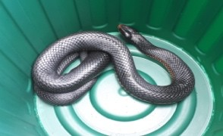
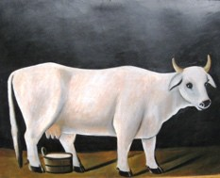
  - B.

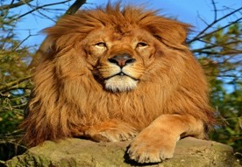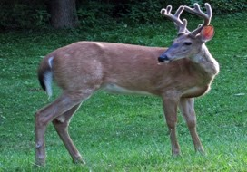
C. D.
- Sonia and Prakesh were discussing about the nature of Parmatma in Sikhism. They agreed that before the universe was created, Parmatma existed all alone as
  - Abhay
  - Murti
  - Saakaar
  - Nirgun.

- Pavan Guru paani pita mata dharat mahat
From the above statement, the Panch- Mahabhoot that is given higher status in Sri Guru Granth Sahib ji is
  - fire
  - air
  - water
  - earth.

- Covid-19 is a pandemic that has killed many people. The teaching of Enlightened Beings that you will follow in order to be saved from the disease is
  - Shaucham
  - Brahmacharya
  - Pranidaya
  - Satya.
- Choose the Scripture that has been
correctly matched with its faith.
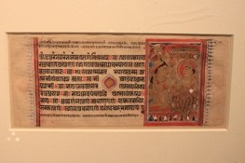
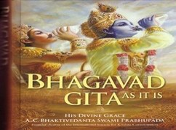
  - Jainism B. Sikhism
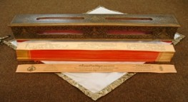
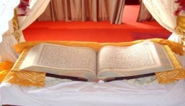
C. Sanatan D. Buddhism

- Sarkar wanted to know why the law of Karma is important in Bhagwat Gita. Amrit explained to him that the law of Karma guides the devotees to
  - choose their destiny in life
  - enhance their spirituality
  - perform rituals in the correct manner
  - choose right deeds always.

- The Grade Six teacher was preparing learners for an end of year assessment. He advised them to follow the principle of
  - Prarthana
  - Purushartha
  - Punarjanam
  - Pranidaya.

- The following are Lord Buddha’s teachings
- There is suffering
- Suffering can be traced
- Suffering can be brought to an end

According to Lord Buddha one can overcome the sufferings by
- giving solace to the sick
- working hard for a better future
- controlling the worldly desires
- meditating in the Stupa always.

- Anwai visited the Budhist temple with his parents for a festival. The main ceremony that was performed there is

  - Vesak
  - Vaisakhi
  - Vishakha
  - Visakha Bucha Day.

- The following are the features that are found in a place of worship.

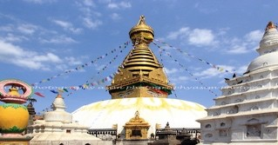

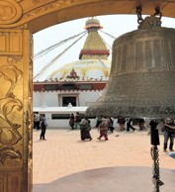

The place of worship that has these features is
  - Church
  - Mandir
  - Stupa (Vihar)
  - Gurdwara.

- Choose the box that contains the activities performed during the festival of Sankraanti.

A B
Till laddoo Kite flying Rice cake
Deepak Rice cakes Rangoli

C D
Exchange gifts Rangoli Flying kites
- Rehema asked the teacher why Diwali is celebrated with a lot of enthusiasm. The teacher responded to her that Diwali is celebrated in order to

  - appreciate the Nirvan of Lord Mahavir
  - commemorate the return of Lord Ram to Ayodhaya
  - remember the wedding of Lord Ram and Sita
  - commemorate the killing of
Narkasur by Lord Krishna.

- Which of the following asanas
has been correctly matched with its right posture?

asanas posture
  - padam asan lotus.
  - sukhasan corpse.
  - tadasan cross legged.
  - Shavasan palm tree.

- Rikil has been paying homage every time she visits the temple. The best way to use the homage that is paid is to
  - decorate the place of worship
  - cook variety of food for devotees
  - help the needy in the society
  - maintain the place of worship.

- The head teacher organized for all the learners to listen to the audio on the story of Lord Krishna and Sudama. The main qualities that learners can learn from the story are
  - patience and tolerance
  - perseverance and compassion
  - friendship and humility
Bonfire Rath yatra Rice cakes
  - tolerance and obedience.

